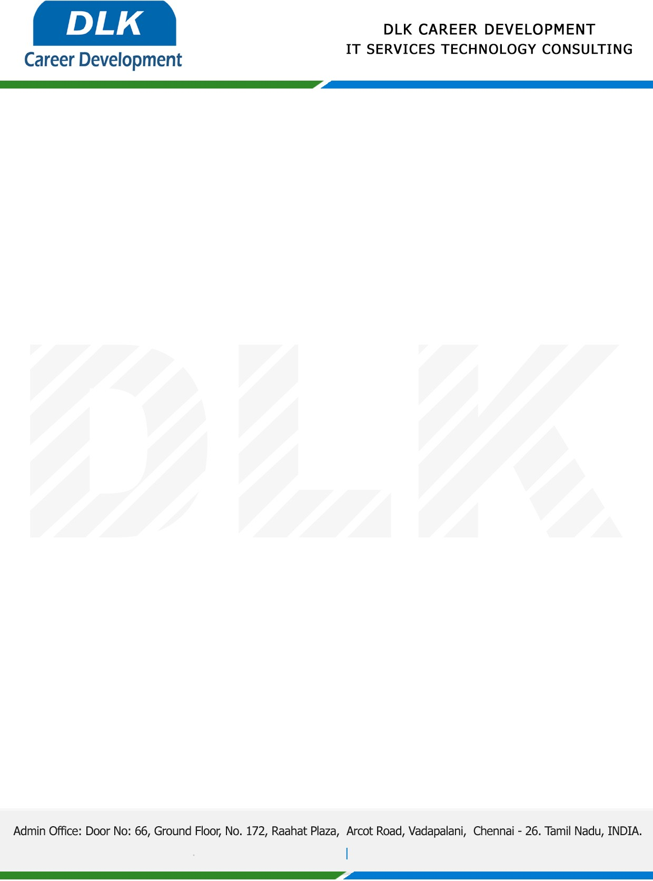

Date: 24/ December / 2022

**To**

Department of BE ([Electronics and Communication),](https://www.cseindia.org/)

Head of Department,

Velammal Engineering College, Chennai - 600066.

**Sub: Letter of Internship Acceptance**

This is to certify that **MS NAVEENAA S (REG NO: 113220041083)** pre-final year student of has accepted her Internship Work duration from **26th December 2022** to **13th January 2023** under the domain ” **WEB DEVELOPMENT”.** During the internship, all information and data collected from your should be kept confidential.

We appreciate your interest in **DLK CAREER DEVELOPMENT**

